Asia-China-Coin-Knife- Qi (400-220 BCE), H 4.5 R 3, mould

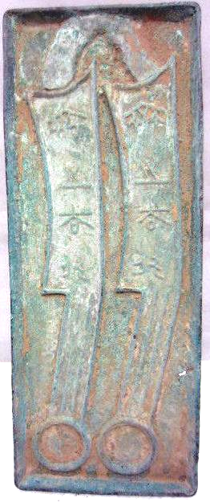 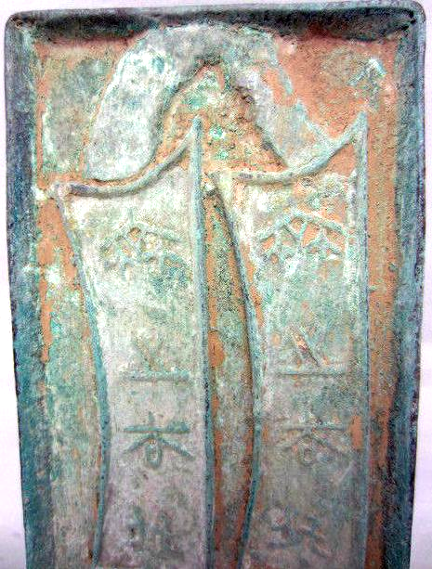

Qi Knife (400-220 BCE), H 4.5 R 3, mould

weight:425g    size: width3inch* height7.7inch

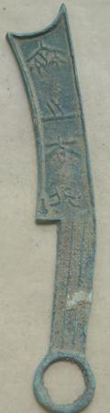 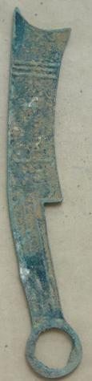

Qi Knife (400-220 BCE), 17cm X2.5cm, The weight：35gm., H 4.5 R 3

Order details Printer friendly page

Sold by

[nl2222](http://myworld.ebay.com/nl2222) ( [427](http://feedback.ebay.com/ws/eBayISAPI.dll?ViewFeedback&userid=nl2222)  )

+ Show additional actions

Delivery package 1 of 1

Estimated delivery Wednesday, Jan 8, 2014 - Thursday, Jan 16, 2014

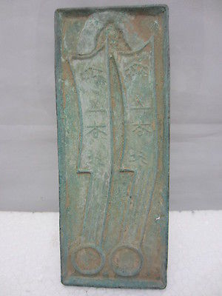

[Chinese bronze production mould of ancient commodity circulation use](http://www.ebay.com/itm/221329023774)

Item price

$40.00

Quantity

1

Item number

221329023774

Shipping service

ePacket delivery from China

[Leave feedback](http://feedback.ebay.com/ws/eBayISAPI.dll?LeaveFeedbackShow&useridfrom=802-867&useridto=nl2222&item=221329023774&transactid=1305302519012) [Contact seller](http://contact.ebay.com/ws/eBayISAPI.dll?FindAnswers&frm=3998&iid=221329023774&redirect=0&requested=nl2222) [Return item](http://return.ebay.com/ws/eBayISAPI.dll?ResolveReturn&eventName=viewSelectedItem&TransactionId=1305302519012&ItemId=221329023774)

### Shipping address

Ralph J Coffman Jr  
149 Atlantic Ave   
Swampscott MA 01907-2427  
United States

Phone number  
781 584 7091

### Order total

Subtotal $40.00

Shipping Free

#### Total

## $40.00

[View PayPal transaction](http://payments.ebay.com/ws1/eBayISAPI.dll?IntermediateResolutionInfo&itemid=221329023774&transId=1305302519012&pn=UnifiedCheckoutSummaryRedirect2PP&qs=itemid%3D221329023774%26transId%3D1305302519012%26buyerorseller%3D0%26)

### Order information

Order placed on  
Saturday, Dec 28, 2013

Having a problem with this purchase?  
[Resolve problem](http://res.ebay.com/ws/eBayISAPI.dll?ResolutionCenter)

Payment method   
PayPal

Payment date  
Saturday, Dec 28, 2013

======================

# Vintage China Ancient Bronze Four words knife-shaped coin Statue

### Seller information

|  |  |
| --- | --- |
|  |  |

[hzfeng197388](http://myworld.ebay.com/hzfeng197388?_trksid=p2047675.l2559) ([734](http://feedback.ebay.com/ws/eBayISAPI.dll?ViewFeedback&userid=hzfeng197388&iid=271350072195&ssPageName=VIP:feedback&ftab=FeedbackAsSeller&rt=nc&_trksid=p2047675.l2560) )

98.3% Positive feedback

[Follow this seller](http://www.ebay.com/itm/Vintage-China-Ancient-Bronze-Four-words-knife-shaped-coin-Statue-/271350072195?nma=true&si=5L4Tlo08dyY9pQflhUEb6fWvMTI%253D&orig_cvip=true&rt=nc&_trksid=p2047675.l2557)

[See other items](http://www.ebay.com/sch/hzfeng197388/m.html?item=271350072195&nma=true&rt=nc&si=5L4Tlo08dyY9pQflhUEb6fWvMTI%253D&orig_cvip=true&_trksid=p2047675.l2562)

Visit store:

[hzfeng197388](http://stores.ebay.com/hzfeng197388?_trksid=p2047675.l2563)

Top of Form

## Item Information

Item condition:

--not specified

Ended:

Dec 24, 2013 19:43:55 PST

Winning bid:

US $0.99

[ [1 bid](http://offer.ebay.com/ws/eBayISAPI.dll?ViewBids&_trksid=p2047675.l2565&rt=nc&item=271350072195) ]

|  |  |  |  |
| --- | --- | --- | --- |
|  | Join **eBay Bucks** and earn **%** back on this item. [See conditionsfor eBay Bucks - opens in a new window or tab](http://pages.ebay.com/rewards/terms.html?ssPageName=STRK:VI:LNLK:TCS) | | |
|  | | New customers get $10 back on 1st purchase Subject to credit approval.[See terms](https://apply.billmelater.com/apply?guid=1SJ8TEIO&assetId=NBRVI1213) |  |

Shipping:

$6.00 ePacket delivery from China | [See details](http://www.ebay.com/itm/Vintage-China-Ancient-Bronze-Four-words-knife-shaped-coin-Statue-/271350072195?nma=true&si=5L4Tlo08dyY9pQflhUEb6fWvMTI%253D&orig_cvip=true&rt=nc&_trksid=p2047675.l2557" \l "shpCntId)

Bottom of Form